Onboarding Questionnaire

Brief: We’re very excited to kick-off this project. This will be a lengthy exercise, and the more information you provide, the better. Be as exhaustive as possible, as this is memorializing your brand and will feed into the documentation process, it’s essentially a business and brand dump to get our team up to speed as fast as possible.

Table of Contents
General Business Information 1
Vision, Mission & Values 2
Target Audience 2
Messaging & Tone of Voice 3
Products, Services & Strategy 4
Priorities & Success Metrics 4
Final Thoughts 4

General Business Information
- Business Name:
- Founder/Owner Name(s):
- What’s your story? (How did this business start, and why?)
- What are your business goals for the next 6 months and for 12 months
- What is your annual recurring revenue?
- What is your revenue goal?
- What's working well right now in your business to drive revenue?
- How many people work for you?
- What is your industry?

Vision, Mission & Values
- What is your business’s vision? (The long-term impact you want to make.)
- What is your value proposition and how do you set yourself apart?
- What is your mission? (The day-to-day purpose of your business.)
- What core values drive your business and customer relationships?

Target Audience
- Who is your ideal customer?
  - Demographics (Age, gender, location, income, etc.)
  - Psychographics (Interests, beliefs, goals, challenges, etc.)
- What are their biggest pain points or challenges that your product/service solves? (e.g. subscription based model)
- What objections or hesitations might your target audience have when purchasing your product/service?
- Who are your competitors, and what makes you stand out?
- What Products and Services are you opening with and what is to come?

Messaging & Tone of Voice

- What 3-5 adjectives best describe your brand voice? (e.g., professional, approachable, fun, innovative, authoritative, etc.)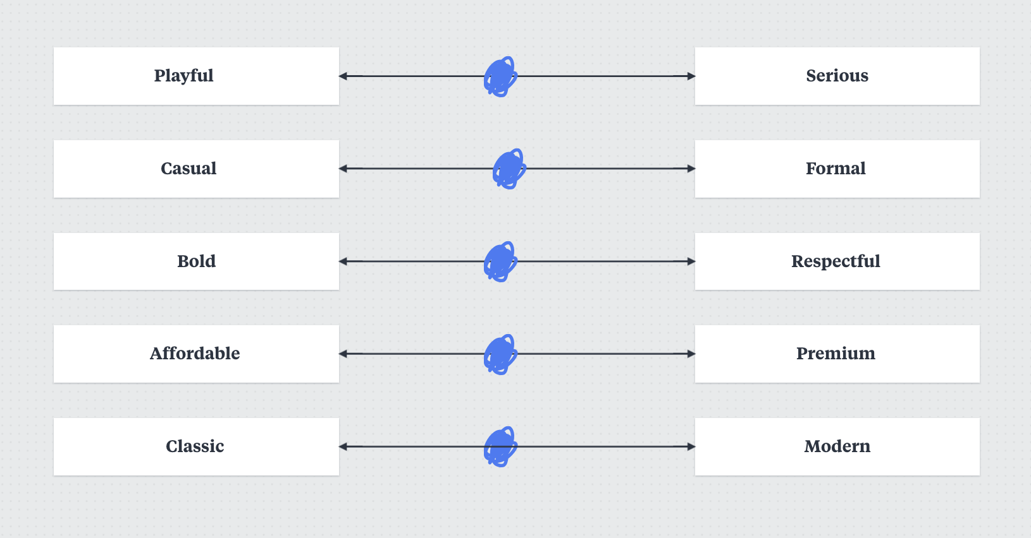
- What feelings or emotions do you want customers to associate with your brand?

Products, Services & Strategy

- What products or services do you currently offer? Flagship offerings and price points: Bundles, discounts, or upsells

- Are you planning to launch any new products or services soon?

Priorities & Success Metrics

What technology do you use & score leads?
What tools do you use for sales and marketing? (CRM, email platforms, analytics, etc.)
How do you nurture leads? (Email marketing, ads, webinars, etc.)

Final Thoughts
What motivates you most about growing your business?
What are your top 3 priorities for the next 90 days?
What outcomes would define a successful collaboration for you?

